Republic of the Philippines

PALAWAN COUNCIL FOR SUSTAINABLE DEVELOPMENT STAFF

Puerto Princesa City

**PCSDS Strategic Plan 2019-2022**

**BACKGROUND**

The Province of Palawan is unique in terms of the richness of its fauna and flora, including species that are locally endemic to the province. It harbors the highest terrestrial and coastal forest cover in the country which makes up 47.8% of its land area in 2010. Its uniqueness and outstanding ecological and cultural character are evident from the 30 identified Key Biodiversity Areas (KBAs), 10 areas proclaimed under the NIPAS, several Certificate of Ancestral Domain Titles (CADTs), and two natural World Heritage Sites and wetlands of international importance under the Ramsar Convention. Notwithstanding these areas of high conservation value, Palawan is a vulnerable island ecosystem because of its long and narrow geography, steep topography, highly erodible and impermeable soils, and small watersheds and rivers, most of which are intermittent in character.

Palawan is in economic transition. Natural resource-based industries such as tourism and oil and gas are booming. People from the rest of the Philippines are migrating to Palawan which is seen as a land of opportunities. However, Palawan coastal and forest ecosystems are undergoing degradation from continuous natural resource extraction and climate change impacts. Majority of the people of Palawan (60%) are below the poverty level which further contributes to the strong demand for natural resources.

**PROGRAM DESCRIPTION**

The Palawan Environmentally Critical Areas Network (ECAN) Management Program ensures that the natural ecosystems of Palawan are conserved, protected, and restored to ensure the long-term provision of ecosystem services to the people. Its objectives are to protect and conserve core zones and other high conservation value areas (HCVAs) of the province, including its threatened unique wildlife species and habitats; and to improve knowledge of the interactions between humans and the Palawan environment. These are accomplished when (i) core zones are protected and buffer and multiple use zones are sustainably managed; (ii) the local ECAN Boards are effective and operationally sustainable; (iii) the participation of local community in environmental planning and management is increased, and (iv) the mechanisms of environmental research, environmental monitoring and evaluation system, and environmental education and extension are strengthened. Satisfying these objectives will ease pressures on Palawan’s natural ecosystems and resources and ensure sustainability of its development projects. Implemented in collaboration with local governments and other concerned agencies/institutions, the program can be a platform to harmonize the three core elements of sustainable development: environmental protection, social inclusion, and economic growth.

**ECAN AS AN INTEGRATED AREA DEVELOPMENT STRATEGY**

The ECAN zoning system is an integrated, ridge-to-reef strategy to safeguard the natural capital of Palawan and properly manage it as a fragile island ecosystem. Its use is legally prescribed in the Strategic Environmental Plan (SEP) for Palawan Act (R.A. No. 7611), a comprehensive framework to guide local governments in planning, policy formulation, and regulating the entry of development projects. ECAN zoning is the process of delineating and marking the boundaries of the different zones on both land and sea, the identification of prescribed activities and resource use for each zone, and the enforcement of regulatory measures to prevent practices that are destructive of the environment.

The ECAN is a priority setting mechanism to identify specific areas for protection and development. Among its many provisions, the ECAN shall ensure the following: conservation and protection of forest, watershed protection, preservation of biological diversity, protection and preservation of tribal culture, protection of the rare and endangered species and their habitat, provision of areas for environmental and ecological research, education and training, and the provision of areas for tourism and recreation. Mainstreaming ECAN into local development plans and programs rationalizes these plans and contributes toward making localities climate change and disaster risk-ready since the objectives of ECAN include the protection of forests (carbon sinks) and prohibition of critical activities in elevated and very steep areas.

The general population of Palawan, projected to increase to 1.33 million by 2018, is expected to economically benefit from program implementation, particularly those who will be covered by ECAN programs and projects adopted and implemented by local government units and conservation groups. The expected improvement of the health of Palawan ecosystems will have positive benefits on human health. Filipinos in other parts of the country who also depend on the continuing flow of natural resource goods and products sourced from Palawan (e.g., fish food, energy from natural gas) will also stand to benefit.

***UNDERPINNINGS***

The principles that underpin the sustainable development framework in Palawan are explicitly identified in R.A. No. 7611 (see table). The possible responses to these principles are shown in the right column of the table below.

| **Key Principles of Sustainable Development (Section 5, R.A. No. 7611)** | **Responses** |
| --- | --- |
| 1. Ecological viability – intact natural ecosystems; conformity of plans, programs, and policies to the ECAN system | 1. Resilient society – adapting to risks of climate change and natural disasters is imperative for a fragile island ecosystem |
| 1. Social acceptability – free, prior, and informed consent by indigenous and local communities; people-oriented programs and policies; communities as the essence of SEP | 1. Rights-based society – focus on the needs of rights holders; building an environmentally conscious and culturally sensitive society |
| 1. Integrated approach – ridge-to-reef; ecosystem-based; multi-sectoral convergence | 1. Knowledge-based and futurist society – prominent role of natural and social sciences; acknowledgement of intergenerational responsibility; multisectoral convergence |

***PURSUIT OF SUSTAINABLE DEVELOPMENT GOALS (SDGs) AT SUBNATIONAL LEVEL***

At the provincial level, the pursuit of sustainable development goals (SDGs) in Palawan Biosphere Reserve was already enshrined in the SEP Act way back in 1992. Section 2 of the law provides that it is the policy of the state to “support and promote the sustainable development goals [SDGs] for the provinces through proper conservation, utilization and development of natural resources to provide optimum yields on a continuing basis.”

Given the strategic importance of Palawan, it must be safeguarded by many Filipinos who appropriate most of its productive areas to provide the fish food and other economically important resources. Investing in its rational development is critical at this point as the province is experiencing rapid economic growth from tourism and other business interests. Also given its fragility and finite carrying capacity, the province’s capacity to absorb growth must be strengthened so that it can respond to these rapid changes while maintaining its intact resources and ecosystems. Included in 1990 as part of the world network of "biosphere reserves" under the Man and the Biosphere (MAB) Programme of UNESCO, Palawan itself is a living laboratory and offers a standard against which to measure human impact on the environment.

***BUILDING A KNOWLEDGE-BASED PALAWAN SOCIETY***

Science, technology, and innovation (STI) play a central role in enabling the international community to respond to sustainable development challenges. This is because a knowledge-based society is one where science informs important policy decisions and actions. According to studies, there is substantial correlation between the most innovative countries and the least corrupt countries. This is a good reason why the most innovative countries make the greatest investment in R & D as a percentage of GNP. They recognize that R & D investment can be increased to produce benefits greater than their costs. There are at least four areas where sustainability science can contribute in achieving SDGs (Colglazier 2015):

1. Comprehending challenges,
2. Defining actions that can make a difference,
3. Monitoring progress, and
4. Pursuing innovative solutions

Consistent to the Philippine Development Plan 2017-2022 vision of laying the groundwork for inclusive growth, a high-trust and resilient society, and a globally competitive knowledge economy, the pursuit of a knowledge-based society in Palawan is a clear and robust approach to build the foundation of sustainable development. The figure below demonstrates the integral place of knowledge in development.

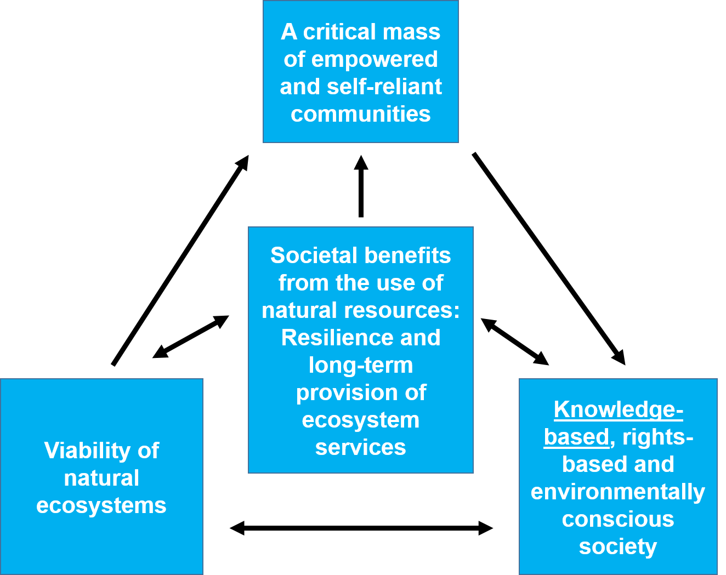

***Figure 1. Knowledge-Ecosystem-People linkages for inclusive development.***

***PROPOSED POLICY AGENDA***

For Palawan ECAN Management Program to proceed with appreciable impact, the following policy concerns are proposed:

* Forest conservation and protection
  + Support for Non-Timber Forest Product (NTFP) industry
  + Conservation of all types of forest formations, particularly lowland forests
  + Mobilization of forest-dependent communities for conservation and enforcement
  + Support to alternative sources to timber as fuel
* Protection of watersheds
  + Declaration of watershed management areas for every municipality
  + Rehabilitation of degraded areas
  + Establishment of permanent stations for periodic monitoring and analysis of water quality
* Preservation of biological diversity
  + Preparing for post-2020 Biodiversity Framework
  + Marine Protected Area Network (MPAN) organization and management
  + Accessing conservation financing windows
  + Leveraging the ecosystem payments and economic incentives from biodiversity conservation
  + Research on ecosystem services
  + Support to protected area management effectiveness
  + Revival of seasonal closure of reef fish food (RFF) fishery, alongside other robust approaches
* Protection of tribal people and the preservation of their culture
  + Sustainability of JFPR 9160 Project
  + Integrating gender concerns in planning and implementation
  + Documentation and preservation of Indigenous Knowledge, Systems and Practices (IKSP)
* Maintenance of maximum sustainable yield
  + Protection of prime agricultural areas
  + Reversion of abandoned, underutilized, and undeveloped (AUU) fishponds
  + Studies on ecosystem support to agricultural productivity
* Protection of the rare and endangered species and their habitat
  + Scientific researches on key species (flagship, endemic, threatened, keystone, indicator)
  + Comprehensive approaches to eliminate wildlife poaching
  + Eradicate environmental crime syndicates
  + Social marketing designed for both the supply and demand sides of wildlife trade
  + Critical habitat planning and project implementation
* Provision of areas for environmental and ecological research, education and training
  + Research and environmental education on hazards and disaster risks
  + Promoting and encouraging the role of sustainability science, engineering, technology and innovation (S-SETI) in building a knowledge-based society
  + Establishment of an information and communication hub to support sustainability research and development, and training
  + Training environmental managers and communities
  + Production and dissemination of strategic communication and learning materials and knowledge products
  + Expanding the role of Palawan Knowledge Platform (PKP) as a learning platform
  + Grassroots participation through community-led projects
  + Institutional convergence
  + Sustainability and policy adoption of ZCR Project
  + Application of innovative tools (CCRES, Phil-WAVES)
  + Amendments to ecological solid waste management
  + Environmental audit of extractive industries
* Provision of areas for tourist and recreation
  + Ecotourism Code of Conduct for tourists and establishments
  + Exploration of various modes of tourism (cultural tourism, agro-tourism, geotourism)
  + Responsible tourism in caves
* Cross-cutting ECAN concerns
  + Provincial Land Use Policy vis-à-vis proposed National Land Use Act
  + Climate Change Mitigation and Adaptation
  + Palawan version of Expanded NIPAS
  + Disaster risk and hazard management
  + Blue carbon ecosystems conservation, education, awareness, and policy development

**PROGRAM IMPLEMENTATION STRATEGIES**

The logical framework for the Palawan ECAN Management Program is shown below. It ties up the organizational outcome (**Natural Resources Sustainably Managed)** to the higher level environmental sector outcomes outlined in the Philippine Development Plan 2017-2022. The activities are based on the program under the Program Expenditure Classification (PREXC) system (also shown below) of the Department of Budget and Management (DBM).

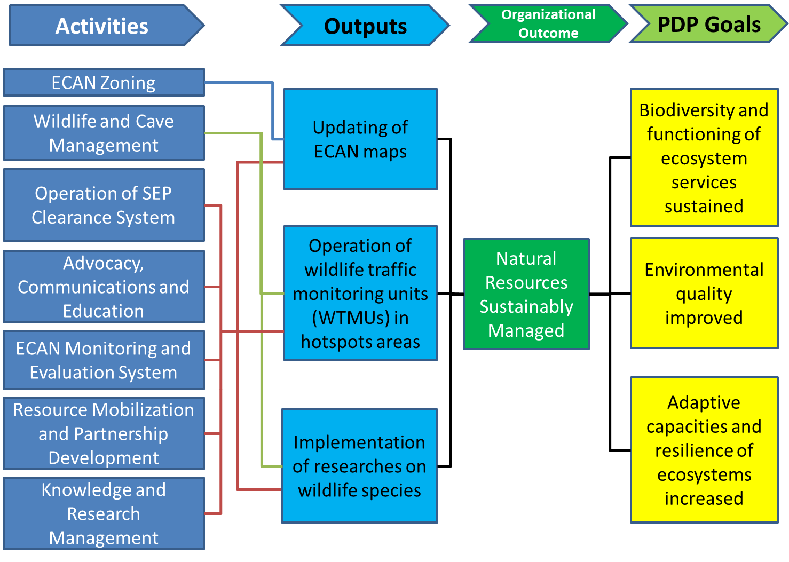

***Figure 2. Environmental sector strategy development framework.***

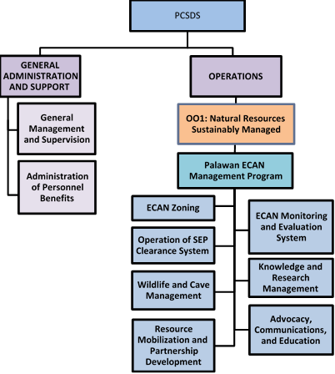

***Figure 3. PCSDS Program Expenditure Classification (PREXC).***

***ACTIVITIES***

There are seven activities of the program.

1. ***Environmentally Critical Areas Network (ECAN) Zoning*** – In order to increase benefits from natural resources (i.e., provisioning, supporting, regulating, and cultural services derived from ecosystems), the SEP framework and ECAN standards are mainstreamed and institutionalized into the planning and decision-making processes of local government units. The major activities under ECAN zoning include the updating of ECAN maps, mainstreaming of ECAN into local land use planning system, formulation of policies and guidelines in support of ECAN, and capacity development of ECAN Boards and key stakeholders for ECAN management. The lead division for this activity is the ECAN Policy Research and Planning Division.
2. ***Wildlife and Cave Management*** – This covers the important aspects of holistic wildlife management: management of species, habitats (including caves), and ecosystems; and empowerment of stakeholders in the conservation and protection of wildlife resources of Palawan. The major strategies here are the protection and co-management of critical habitats and other high conservation value areas (HCVAs), species conservation and management, and regulation of wildlife collection and trade. The lead division for this activity is the ECAN Zones Management and Enforcement Division.
3. ***Operation of Strategic Environmental Plan Clearance System*** – The PCSD issues SEP Clearances to all development undertakings in Palawan. The SEP Clearance System enforces the ECAN system by using the approved ECAN zones maps as the bases for locating projects in appropriate areas. Thus, this activity regulates the entry of environmentally critical projects and developmental activities in Palawan. The lead divisions for this are the ECAN Zones Management and Enforcement Division, and the three District Management Divisions.
4. ***Knowledge and Research Management*** – This activity operates the Palawan Knowledge Platform (PKP), an information clearing house mechanism designed to consolidate and distribute knowledge base on Palawan to a wide variety of users. The solid knowledge and information in PKP will be used to formulate more technically sound plans and policies, develop more robust methodologies for mainstreaming ECAN into local conservation and development plans, and conduct monitoring and evaluation more effectively. The lead division for this activity is the ECAN Monitoring and Evaluation Division, with the support of the other divisions.
5. ***Advocacy, Communications and Education*** – This activity is expected to enhance the biological sensitivity of the people, train them to become effective managers and stewards of the ECAN, and promote public awareness to enable local communities to become fully involved in the conservation and sustainable use of resources. It is being implemented by the ECAN Education and Extension Division which also handles the operations of the Palawan Sustainable Development Training Complex in Puerto Princesa City. The training complex will be physically developed and will become the Palawan Biosphere Reserve Center for Sustainable Development. It will serve as a regular venue for environmental trainings, conferences, and seminars to develop the skills and competency standards of ECAN managers and local stakeholders on sustainability science, human ecology, and climate change.
6. ***ECAN Monitoring and Evaluation System*** – The Environmental Monitoring and Evaluation System (EMES) is established to generate scientific knowledge for the SEP, track progress of its implementation, monitor changes in the environment, and develop scenarios to address critical concerns on land use for the future. It deals with environmental assessment, mapping, and modeling. The system is implemented by the ECAN Monitoring and Evaluation Division.
7. ***Resource Mobilization and Partnership Development*** – This activity involves stakeholder partnership and engagement and development of sustainable financing mechanisms to support ECAN management and implementation. The lead in program development is the ECAN Policy Research and Planning Division.

***PROGRAM RESULTS: PALAWAN BIOSPHERE RESERVE AS AN EFFECTIVELY FUNCTIONING MODEL OF SUSTAINABLE DEVELOPMENT***

The Program is envisioned to contribute to the rationalization of the province's land uses and the wise use of its ecosystems and high-valued resources (e.g., edible bird’s nest, coral grouper, non-timber forest products, abalone, and minerals). A large area of Palawan lands and waters are already being appropriated by consumers outside the province and an overshoot is likely to be already present in some sectors. Hence, sound policies and regulation must be in place to regulate land use development planning and the increased national and international demand for both renewable and non-renewable resources of Palawan.

The major outcome indicators of the program are carefully chosen to (i) measure the management effectiveness of ECAN zones, and (ii) the compliance to the law on wildlife trade. These ‘immediate’ outcomes are chosen for their explanatory power and ease of measurement. The baseline and target for these indicators are found in BP Form B (Agency Performance Measures).

**Results indicators of Palawan ECAN Management Program.**

| **Indicators** | **Accomplishments/Baseline**  **(as of December 31, 2017)** |
| --- | --- |
| **Outcome Indicators and Target** | |
| 1. Increase in management effectiveness of ECAN zones   Target:  +3% increase from baseline score by end of 2018;  +5% increase by end of 2019. | 27.39 average score of ECAN zones for 1 city and 23 municipalities (baseline score) |
| 1. Decrease in percentage of detected trade in wildlife and wildlife products that is illegal   Baseline (2016) = 0.52  Target:  Less than or equal to 0.52 by end of 2018;  Less than or equal to 0.51 by end of 2019 | (Targeted by end of 2018.)  Related accomplishments:  79 seizures/confiscations on wildlife conducted;  11,720 wildlife-related permits issued |
| **Major Output** | |
| 1. 100% of 24 municipal/city ECAN maps updated by 2022 2. 16 or 50% of 31 Critically Endangered Palawan wildlife animal species with population study and species management plan by 2022 3. Functional wildlife traffic monitoring units in 100% of 15 hotspots exit points by 2020 4. Operation and maintenance of the Palawan Center for Sustainable Development which aims to train conservation and development practitioners on sustainability science and to lead transdisciplinary researches on environment and innovation | 1. 17% or 4 out of 24 municipal/city ECAN maps updated 2. (Targeted by end of 2018.) 3. Functional wildlife traffic monitoring units in 53% or 8 out of 15 hotspots exit points 4. Operation and maintenance of the Palawan Center for Sustainable Development which aims to train conservation and development practitioners on sustainability science and to lead transdisciplinary researches on environment and innovation |

***STRENGTHENING OF THE PALAWAN BIOSPHERE RESERVE CENTER FOR SUSTAINABLE DEVELOPMENT***

An additional critical output of the program is the promotion and operation of the Palawan Biosphere Reserve Center for Sustainable Development (PBRCSD). The PBRCSD is a physical facility envisioned to be the world-class learning, research, and training platform ran by a pool of experts coming from various recognized institutions in Palawan and beyond. It aims to provide training services, to facilitate collaborative and transdisciplinary researches that will provide scientific evidence to inform public policy decisions, and to build a community of practice (CoP) in sustainability studies and human ecology. It is conceived to be an information and communication hub supporting sustainability research, innovation, and learning, with the ultimate goal of building a knowledge-based society in Palawan. To operationalize this project, a Memorandum of Understanding was already signed among the PCSDS, the Provincial Government of Palawan, the City Government of Palawan, the University of the Philippines (UP) System, and the UP Alumni Association. The participation of higher education institutions, such as the Palawan State University, Western Philippines University, Holy Trinity University, Fulbright College, and other universities and colleges shall also be tapped.

***ROADMAP USING THEORY OF CHANGE FRAMEWORK***

The Palawan ECAN Management program was refined and clarified using a theory of change (TOC) approach developed by United States Agency for International Development (USAID). The first step in a TOC framework was developing a situation model (USAID 2016a), followed by formulating results chains (USAID 2016b) as graphical illustration of TOC, and then defining outcomes and performance indicators in a Monitoring and Evaluation Plan (USAID 2016c).

LOGIC MODEL AND RESULTS CHAIN

The logical framework (logframe) of the environment and natural resources (ENR) sector from the Philippine Development Plan 2017-2022 served as a guide in developing a logical model for the Palawan ECAN Management Program. The outcomes in the logframe were elaborated further using the TOC framework. Following the sequential process developed by USAID, a situation model is developed for Palawan which served as the basis for constructing a results chain depicting the program theory of change. The results chain was developed with a view toward adaptive implementation and managing for results.

IMPLEMENTATION STRATEGIES FOR FY 2019

The following strategic objectives and outcome statements are derived from the program TOC.

|  |
| --- |
| **Intermediate Outcomes** |
| 1. Natural ecosystems conserved, protected, and restored 2. Viable populations of all indigenous wildlife species and their habitats maintained 3. Capacities of institutions and communities in ECAN management improved 4. Comprehensive, modern, open, transparent, and participatory ECAN decision support system institutionalized 5. Sustainability of natural resource-based industries of high economic value ensured 6. Sufficient and sustainable funding for ECAN management secured |
| **Strategic Approaches (SAs)** |
| **Overarching SA. CONSERVATION SITES: *Strengthened*** conservation sites for sustainability and learning  **SA 1. ADVOCACY, COMMUNICATIONS, AND EDUCATION: *Improved*** knowledge of communities and stakeholders on the benefits and values of conserving ECAN and biodiversity  **SA 2. ECAN ZONING: *Mainstreamed*** ECAN zoning and resource use management into local and national planning system  **SA 3. KNOWLEDGE MANAGEMENT: *Strengthened*** research, innovation, and knowledge base in Palawan  **SA 4. TRAINING CENTER: *Established*** training center for sustainable development  **SA 5. SEP CLEARANCE SYSTEM AND PERMITTING: *Ensured*** environmental, sociocultural, and economic sustainability of conservation and development projects and programs  **SA 6. ENFORCEMENT AND WILDLIFE CONSERVATION AND PROTECTION: *Effectively managed*** wildlife resources and high conservation value areas |

SPECIFIC OBJECTIVES

The specific objectives of each of the seven activities of the program are enumerated below.

|  |  |
| --- | --- |
| 1. ECAN ZONING | 1.1 Protect core zones and sustainably manage buffer and multiple use zones 1.2 Mainstream and institutionalize the ECAN system and standards into the public sector and local planning system |
| 2. WILDLIFE AND CAVE MANAGEMENT | 2.1 Establish and protect critical habitats and other high conservation value areas 2.2 Conserve and protect threatened indigenous wildlife species of Palawan and their habitats  2.3 Increase efficiency in environmental law enforcement in environmental crime hotspots areas |
| 3. ADVOCACY, COMMUNICATIONS AND EDUCATION | 3.1 Increase environmental awareness of indigenous and local communities (ILCs) in key conservation areas and hotspots areas |
| 4. ENVIRONMENTAL MONITORING AND EVALUATION SYSTEM | 4.1 Ensure a reliable decision support system for sound and practical policy decisions and actions 4.2 Measure the impact of SEP and the attainment of Palawan sustainable development goals (SDGs) |
| 5. KNOWLEDGE AND RESEARCH MANAGEMENT | 5.1 Generate and disseminate updated scientific information on Palawan 5.2 Strengthen cooperation and exchange of information among partner stakeholders |
| 6. OPERATION OF STRATEGIC ENVIRONMENTAL PLAN (SEP) CLEARANCE SYSTEM | 6.1 Regulate the entry of environmentally critical projects and activities 6.2 Ensure compliance of conservation and developmental projects to ECAN regulations and environmental rules and regulations |
| 7. RESOURCE MOBILIZATION AND PARTNERSHIP DEVELOPMENT | 7.1 Develop effective external partnerships for ECAN program implementation 7.2 Secure sufficient and sustainable funding for ECAN program implementation |

PCSDS THEORY OF CHANGE

The following statement constitutes the working theory of change of PCSDS.

**IF** sustainable development knowledge, attitudes, and practices are ***mainstreamed*** to all projects and undertakings of indigenous and local communities, civil society, academe, national government agencies, local governments, private investors, women and youth, and international community through the following strategic approaches:

1. ***Strengthened*** conservation sites for demonstration, sustainability, and learning
2. ***Improved*** knowledge of communities and stakeholders on the benefits and values of conserving ECAN and biodiversity;
3. ***Mainstreamed*** ECAN zoning and resource use management into local and national planning system;
4. ***Strengthened*** research, innovation, and knowledge base in Palawan;
5. ***Established*** training center for sustainable development;
6. ***Ensured*** environmental, sociocultural, and economic sustainability of conservation and development projects and programs; and
7. ***Effectively managed*** wildlife resources and high conservation value areas,

**THEN,** PCSDS can substantially contribute to the prevention of biodiversity loss; protection of forests, watersheds, and coastal ecosystems; and increase in adaptive capacity and resilience of people and ecosystems,

**THEREBY,** sustaining the functioning of ecosystems to deliver goods and services for the benefit and welfare of resource-based communities and all people relying on Palawan’s natural resources.

***2019-2022 PRIORITIES***

*PRIORITY 1. STRENGTHENING OF PALAWAN CONSERVATION SITES FOR DEMONSTRATION, SUSTAINABILITY, AND LEARNING*

Palawan is only one of the three biosphere reserves (BRs) in the country, along with Puerto Galera and Albay. In 2017, these three sites agreed to form the Philippine Network of Biosphere Reserves. There is a wealth of experience and innovative potential that can be gleaned in the BRs’ strategies to create a sustainable future amidst the challenges of biodiversity loss and climate change.

As part of the World Network of Biosphere Reserves since 1990, Palawan is in a good position to demonstrate knowledge tools, mechanisms, systems, practices, and collaborative arrangements in the sustainable management of its key conservation sites. Biosphere reserves are areas of terrestrial and coastal/marine ecosystems, which are internationally recognized within the framework of UNESCO's Man and the Biosphere (MAB) Programme, in accordance with the 1995 Statutory Framework for the World Network of Biosphere Reserves.

Each reserve is designed to promote solutions reconciling the conservation of biodiversity with its sustainable use. Palawan Biosphere Reserve consists of sites that can serve as models for testing interdisciplinary approaches to understanding and managing changes and interactions between social and ecological systems, including conflict prevention and the conservation of biodiversity.

The goal of the project is to ensure that Palawan Biosphere Reserve consists of effectively functioning sites for sustainability, by continuously improving governance, collaboration and networking within the BR; developing effective external partnerships to ensure long-term viability; and implementing an effective periodic review process so that all BR demonstration sites adhere to the local standards of the SEP and ECAN, its main strategy.

The successes, crucial learnings, and behavior change strategies introduced in each functional model site will be documented through case studies, knowledge products, and strategic communication materials for replication and uptake in other areas. An effectively functioning conservation site incorporates into its management system concerns such as climate change, gender and development, biodiversity, and inclusive development.

The main objective of the project is to promote knowledge and awareness of Palawan conservation sites among local and international stakeholders.

The specific objectives are:

1. communicate the experiences and lessons learned in conservation sites, facilitating the diffusion and application of sustainability models;
2. support evaluation and high-quality management, strategies, and policies for sustainable development and planning; and
3. work with stakeholders to meet their sustainable development goals through experiences within the conservation sites.

The following framework illustrates the approach in Palawan conservation sites.

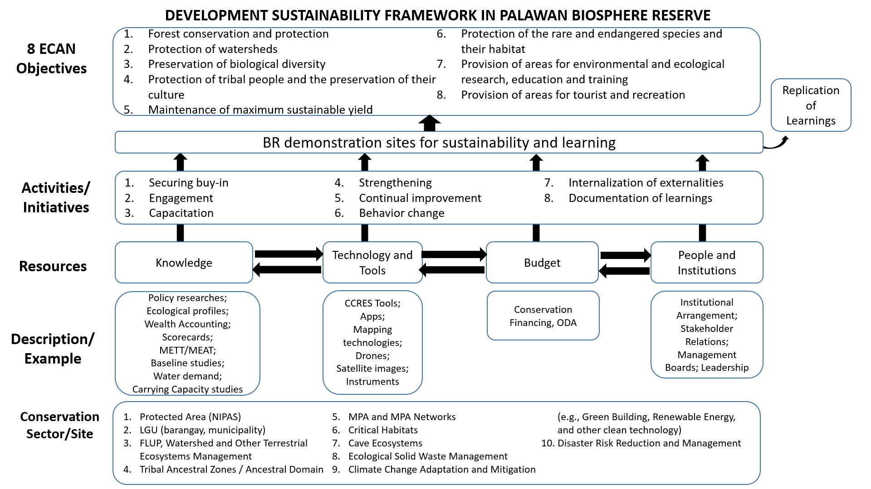

***Figure 4. Development Sustainability Framework in Palawan Biosphere Reserve.***

*PRIORITY 2. PALAWAN WILDLIFE MANAGEMENT PROGRAM*

A portion of the Automatic Appropriations under the Wildlife Management Fund-Special Account in the General Fund (WMF-SAGF) will be used to support activities mandated under Wildlife Resources Conservation and Protection Act (R.A. No. 9147). The Fund shall finance and support the following (Sec. 29, R.A. 9147):

1. rehabilitation or restoration of habitats affected by acts committed in violation of R.A. No. 9147,
2. scientific research,
3. enforcement and monitoring activities, and
4. enhancement of capabilities of relevant agencies.

The goals of Palawan Wildlife Management Program are to prevent the loss or leakage of Palawan biological diversity, promote ecological balance, and enhance biological diversity by ensuring that the species including their habitats and ecosystems are conserved and protected. The strategies to achieve these are to regulate the collection and trade of wildlife resources; initiate and support scientific studies on the conservation of biological diversity; and pursue, with due regard to the national interest, the Philippine commitment to international conventions on the protection of wildlife and their habitats.

The main objective of the program is to effectively manage wildlife resources and high conservation value areas. Its specific objectives are:

1. increase understanding of wildlife resources and their habitats,
2. enhance capacity of enforcement agencies and communities,
3. restore degraded habitats and ecosystems with the involvement of communities, and
4. increase efficiency of environmental law enforcement in hotspots areas.

The results chain highlighting these four objectives is shown below.

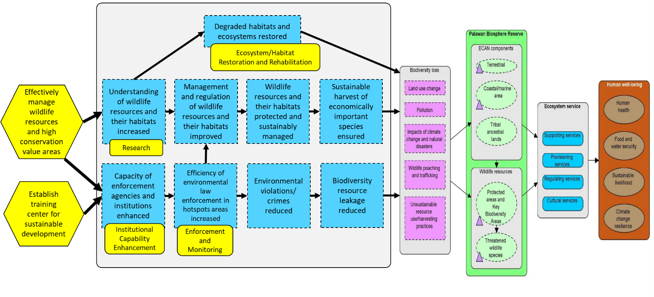

***Figure 5. Results Chain of Palawan Wildlife Management Program.***

The program is tagged as a climate change adaptation activity for its contribution to species and ecosystems management in the face of climate challenges. The direct impact of climate change on wildlife population is one of the gaps in wildlife management in Palawan. Based on what is known of the behavior of natural species and ecosystems under disturbance, the stability and resilience of wildlife populations and their habitats will be affected depending on the magnitude of disturbance. The major effects of climate change that directly or indirectly impacts wildlife communities and human population include habitat loss, stress to ecosystems and to species, and the consequent loss of ecological goods and service values. The limitation of species home range due to the destruction of their habitats may lead to their displacement and extirpation.

Palawan is one of the best observatories for climate change action to support wildlife conservation. Addressing the adverse impacts of climate change to wildlife communities requires an integrated approach that considers adaptation planning at both ecosystem and species levels. It necessitates the co-implementation of climate action with other conservation objectives like forest protection and biodiversity conservation. The uncertain and not easily quantifiable effect of climate change on organisms is such that adaptation action have to be both careful and deliberate. The set of actions has to be careful in order to avoid maladaptation, and it has to be deliberate because of the potential decimating effect on species.

**INSTITUTIONAL ARRANGEMENTS**

The lead divisions within PCSDS for the component activities of the program are as follows:

1. *ECAN Zoning* – The lead division for this activity is the ECAN Policy Research and Planning Division.
2. *Wildlife and Cave Management* – The lead division for this is the ECAN Zones Management and Enforcement Division.
3. *Knowledge and Research Management* – The lead division for this activity is the ECAN Monitoring and Evaluation Division.
4. *ECAN Monitoring and Evaluation System* – The system is implemented by the ECAN Monitoring and Evaluation Division.
5. *Advocacy, Communications and Education* – It is being implemented by the ECAN Education and Extension Division.
6. *Operation of SEP Clearance System* – The lead divisions for this are the ECAN Zones Management and Enforcement Division, and the three District Management Divisions.
7. *Resource Mobilization and Partnership Development* – The lead in program development is the ECAN Policy Research and Planning Division.

**SUMMARY OF BUDGET REQUIREMENTS (2019)**

The total proposal of PCSDS for FY 2019 (based on the National Expenditure Program as recommended by the DBM) amounts to Php127.496 million, broken down as follows:

**FY 2019 PCSDS Budget Proposal (based on the NEP as recommended by DBM).**

| **PCSDS** | **TIER 1** | | | | | **TIER 2** | | |
| --- | --- | --- | --- | --- | --- | --- | --- | --- |
| **Physical Target** | **Budget ('000)** | | | |  | **Palawan Wildlife Management Program** | |
| **PS** | **MOOE** | **CO** | **TOTAL** | **PS** | **Physical** | **Budget ('000)** |
| General Management and Supervision |  | 15,944 | 13,408 | 7,897 | 37,249 | 231 |  |  |
| Palawan ECAN Management Program  (*Regular Appropriations*) | • 4 ECAN maps updated  • 2 endemic species subjected to population studies  • 6 out of 15 functional wildlife traffic monitoring units (WTMUs) established | 32,771 | 22,595 | 18,258 | 73,624 |  |  |  |
| Palawan ECAN Management Program  (*Wildlife Management Fund - Special Account in the General Fund*) | • Additional 6 out of 15 functional wildlife traffic monitoring units (WTMUs) established  • 2 critical habitats assessed  • 12 monthly monitoring of reef fish food (RFF) operations conducted with reports prepared |  | 7,100 |  | 7,100 |  | • Additional 1 out of 15 wildlife traffic monitoring units (WTMUs) that are functional  • 5 wildlife researches implemented • 6 critical watersheds identified, assessed, and delineated in 6 northern Palawan Mainland municipalities | 4,790 |
| RLIP |  | 4,502 |  |  | 4,502 |  |  |  |
| Total |  | **53,217** | **43,103** | **26,155** | **122,475** | **231** |  | **4,790** |
| **Grand Total** | **127,496** | | | | | | | |

**SUMMARY OF ALLOTMENT (2019)**

* **PhP3.300 million** for the updating and ground validation of 4 municipal ECAN maps
* **PhP4.025 million** for environmental education and extension and environmental monitoring and evaluation (water quality analyses, GIS operations, publication of 1 scientific journal, and hosting of National Conference on Sustainable Development)
* **PhP3.853 million** for the operation of SEP Clearance System, including the issuance of 120 SEP Clearances and compliance monitoring
* **PhP4.090 million** for population study of 2 endemic species, and implementation of national environmental laws mandated to PCSD
* **PhP11.890 million** from the Wildlife Management Fund for institutional capability enhancement; assessment and delineation of 6 critical watersheds and 1 critical habitat; and operations of 13 wildlife traffic monitoring units (WTMUs)
* **PhP22.332 million** for the purchase of ICT equipment as indicated in the approved PCSDS Information Systems Strategic Plan (ISSP).
* **PhP6.6 million** for the purchase of 3 motor vehicles for further support of field operations
* **PhP5.1 million** forfurniture and fixtures for the training center and to replace nonfunctional items in the offices

**SUMMARY OF TARGETS (2019)**

1. Updating and ground validation of 4 municipal ECAN maps

* Municipality of El Nido (by end of June 2019)
* Municipality of Bataraza (by end of June 2019)
* Municipality of Roxas (by end of September 2019)
* Municipality of San Vicente (by end of September 2019)

2. Population studies of endemic species

* Palawan Pangolin (*Manis culionensis*) (by end of June 2019)
* Blue-naped Parrot (*Tanygnathus lucionensis*) (by end of September 2019)

3. Implementation of Palawan Wildlife Management Program

| **Activity** | **Details** | **Budget (’000)** |
| --- | --- | --- |
| Wildlife and Cave Management | ***Wildlife research:*** |  |
| • 3 Critical habitats assessed | 800 |
| • 1 Cave survey, resource assessment, and classification | 150 |
| • Development of tool to monitor, measure, and evaluate cave ecosystem health | 150 |
| ***Enforcement and monitoring:*** |  |
| • 25 Enforcement staff hired and deployed | 126 |
| • 9 Enforcers hired and deployed | 1,299 |
| • 7 Functional WTMU established or operationalized | 3,258 |
| • 11 Reef fish food (RFF) inspectors hired and deployed | 1,725 |
| • 12 Monthly inspections for implementation of RFF policy | 442 |
| • 2 Monitoring of caves including capability building of stakeholders in implementation of cave management plans | 400 |
| • Compliance monitoring of wildlife permittees | 900 |
| ***Institutional capability enhancement:*** |  |
| • 4 Preparatory workshops attended for Convention on the International Trade of Endangered Species of Wild Flora and Fauna (CITES) Conference of Parties (COP 18) | 200 |
| • Local training of enforcement staff on criminal justice | 200 |
| • Attendance to 2 foreign meetings pursuant to international commitments on United Nations Convention on Biological Diversity (CBD) and Convention on International Trade of Endangered Species of Wild Fauna and Flora (CITES) | 200 |
| Advocacy, Communications and Education | ***Institutional capability enhancement:*** |  |
| • 2 batches of training for local governments on site and species management for Palawan wildlife | 200 |
| • 1 Youth Wildlife Savers Club Eco-Camp | 100 |
| ECAN Zoning | ***Wildlife research:*** |  |
| • Population studies on 1 wildlife species | 500 |
| ***Ecosystem/Habitat restoration and rehabilitation:*** |  |
| • 6 critical watersheds identified, assessed, and delineated in 6 northern Palawan Mainland municipalities | 600 |
| • Biological, ecological, and cultural research of 1 Indigenous Community Conserved Area | 300 |
| Knowledge and Research Management | ***Wildlife research:*** |  |
| • Wildlife Species Distribution and Habitat Modelling in Northern Palawan | 340 |
| **TOTAL** |  | **11,890** |